File Upload scenario
Weak Prompt: "Generate test cases for file upload."
Result: Here’s a comprehensive set of file upload test cases, covering functional, validation, security, usability, and edge scenarios.
ID | Test case | Expected result
TC-01 | Upload a valid file with supported extension | File uploads successfully
TC-02 | Upload the smallest allowed file | Upload succeeds
TC-03 | Upload a file exactly at the maximum size limit | Upload succeeds
TC-04 | Upload a file larger than the maximum size | Upload is rejected with a clear error
TC-05 | Upload an unsupported file type | Upload is rejected
TC-06 | Upload a file with an uppercase extension (FILE.PDF) | Behavior follows supported-extension rules
TC-07 | Upload a file with multiple extensions (file.pdf.exe) | File is rejected if potentially unsafe
TC-08 | Upload a file with no extension | Appropriate validation/error is shown
TC-09 | Upload a zero-byte file | File is rejected if empty files aren't allowed
TC-10 | Upload a corrupted file | File is rejected or handled gracefully
TC-11 | Upload a file with special characters in the filename | File uploads and filename is handled safely
TC-12 | Upload a file with spaces in the filename | File uploads successfully
TC-13 | Upload a very long filename | Validation/handling is graceful
TC-14 | Upload duplicate files | Behavior matches product requirements
TC-15 | Upload multiple valid files | All files upload successfully if multi-upload is supported
TC-16 | Mix valid and invalid files in a multi-upload | Valid files are handled correctly and invalid files are reported
TC-17 | Cancel an upload in progress | Upload stops and UI returns to the appropriate state
TC-18 | Upload using drag and drop | File uploads successfully
TC-19 | Upload using the file picker | File uploads successfully
TC-20 | Refresh the page during upload | System handles interruption without corruption

Strong Prompt using ICEPOT framework”
Context :
Generate test cases for Insurance domain for File upload functionality requires testing across multiple vectors: file attributes, user actions, boundary limits, and security vulnerabilities.
Instruction:
[strict]Functional only - Positive/negative
[mandatory]Upload allowed formats (e.g., .pdf, .png, .docx) and size upto 50MB and verify successful processing.
[Priority] Generate only 10 testcases
[High Priority] Generate P1 and P2 testcases
[Critical] Generate positive and negative Testcases

Example
TC_ID|Scenario|Steps to execute|test data|expected result|designed by|reviewed by|review comments
Persona
Generate test case as a senior test engineer
Review test case as a test lead
Output
Generate test case in excel format and it should be downloadable
Tone:
Professional and concise

Result:
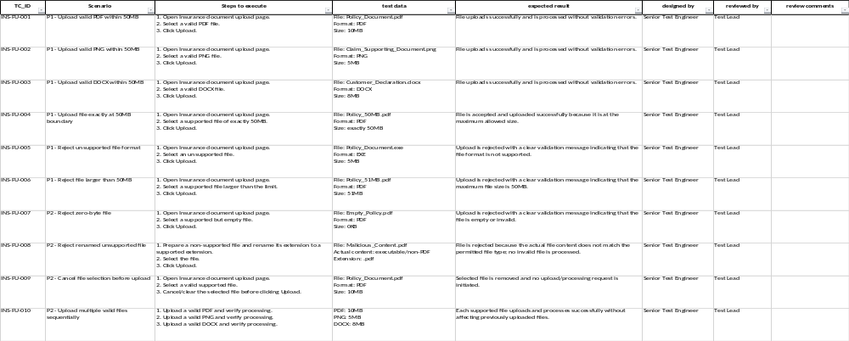

Scenario 2: Role-Based Access Control

Week Prompt: ‘Write test cases for user roles.’

Result:
Sure. Below are functional positive and negative test cases for User Roles, focusing on role creation, assignment, permissions, access control, and role modification.
TC ID | Test Case | Type | Priority
UR-01 | Verify admin can create a new user role with valid role name and required details | Positive | P1
UR-02 | Verify system prevents creation of a role with a duplicate role name | Negative | P1
UR-03 | Verify role cannot be created without entering the mandatory role name | Negative | P1
UR-04 | Verify admin can assign a valid role to an existing user | Positive | P1
UR-05 | Verify assigned user can access only the modules/pages permitted for the assigned role | Positive | P1
UR-06 | Verify user cannot access a module/page that is not permitted for the assigned role | Negative | P1
UR-07 | Verify user cannot perform an action for which the assigned role does not have permission | Negative | P1
UR-08 | Verify admin can modify the permissions of an existing role | Positive | P1
UR-09 | Verify permission changes are reflected for users assigned to the modified role | Positive | P1
UR-10 | Verify admin can remove/revoke a role from an existing user | Positive | P1
UR-11 | Verify user loses access to role-specific functionality after the role is revoked | Negative | P1
UR-12 | Verify system prevents unauthorized users from creating or modifying roles | Negative | P1
UR-13 | Verify role name accepts valid characters according to the defined validation rules | Positive | P2
UR-14 | Verify system displays appropriate validation when an invalid role name is entered | Negative | P2
UR-15 | Verify role details remain unchanged when the user cancels the edit operation | Positive | P2
UR-16 | Verify deleting a role requires confirmation before deletion | Positive | P2
UR-17 | Verify a role currently assigned to users cannot be deleted without handling the existing assignments | Negative | P1
UR-18 | Verify role list displays all available roles with correct details | Positive | P2
UR-19 | Verify search/filter functionality returns the correct roles | Positive | P2
UR-20 | Verify unauthorized users cannot access the User Roles page directly using its URL | Negative | P1

Strong Prompt using ICEPOT framework”
Context :
Generate test cases for HRMS domain for Leave module functionality requires testing across multiple vectors: Create leave request, Revoke leave request, Approve/Request Leave request for roles like HR, Employee and Manager.
Instruction:
[strict]Functional only - Positive/negative
[mandatory] All Employee can create and revoke their own leave request.
[Critical] Manager can only see the leave request of their assigned employee only and those request only can Approve/Request Leave request by manager.
[Critical] HR can see all the leave request in the organization level and HR can Approve/Request Leave request after adding comments to the respective manager.
[Priority] Generate only 10 testcases
[High Priority] Generate P1 and P2 testcases

Example
TC_ID|Scenario|Steps to execute|test data|expected result|designed by|reviewed by|review comments
Persona
Generate test case as a senior test engineer, Review test case as a test lead
Output
Generate test case in excel format and it should be downloadable
Tone:
Professional and concise.

Result:
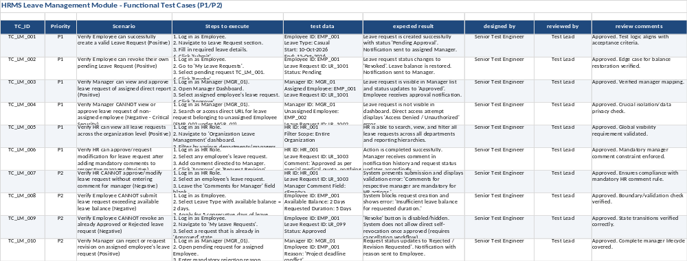
Scenario 3: Role-Based Access Control

Week Prompt: ‘Test the cart functionality.’

Result:
Below is a functional test checklist for Cart functionality, covering positive and negative scenarios.

TC ID | Test Scenario | Type | Priority
CART-001 | Add a single product to the cart | Positive | P1
CART-002 | Add multiple different products to the cart | Positive | P1
CART-003 | Add the same product multiple times | Positive | P1
CART-004 | Verify product details in cart match the selected product | Positive | P1
CART-005 | Increase product quantity from the cart | Positive | P1
CART-006 | Decrease product quantity from the cart | Positive | P1
CART-007 | Remove a product from the cart | Positive | P1
CART-008 | Remove all products and verify empty-cart state | Positive | P1
CART-009 | Verify cart subtotal is calculated correctly | Positive | P1
CART-010 | Verify total quantity is updated after adding/removing products | Positive | P1
CART-011 | Refresh the cart page and verify cart contents are retained | Positive | P1
CART-012 | Navigate away from cart and return; verify cart contents | Positive | P2
CART-013 | Verify cart contents persist after logout/login, if persistence is supported | Positive | P2
CART-014 | Attempt to set quantity to zero | Negative | P1
CART-015 | Attempt to enter a negative quantity | Negative | P1
CART-016 | Attempt to enter a non-numeric quantity | Negative | P1
CART-017 | Attempt to exceed the product's available stock | Negative | P1
CART-018 | Verify unavailable/out-of-stock product cannot be purchased | Negative | P1
CART-019 | Verify cart handles a product becoming out of stock after it was added | Negative | P1
CART-020 | Verify cart total updates when product price changes, if applicable | Positive | P2

Strong Prompt using ICEPOT framework”

Context :
Generate test cases for E-commerce domain for cart module functionality requires testing across multiple vectors: add/remove/update item actions in cart.
Instruction:
[strict]Functional only - Positive/negative
[mandatory] All available items are able to add/remove/update in cart by user
[Critical] user can't add the items which are out of stock to cart.
[Critical] User can able to add multiple different items to cart and able to add +1 quantity for same item in cart.
[Priority] Generate only 10 testcases
[High Priority] Generate P1 and P2 testcases

Example
TC_ID|Scenario|Steps to execute|test data|expected result|designed by|reviewed by|review comments
Persona
Generate test case as a senior test engineer, Review test case as a test lead
Output
Generate test case in excel format and it should be downloadable
Tone:
Professional and concise

Result:
